Your Name_________________________________________

Paul Memorial Library: The Week Junior Contest
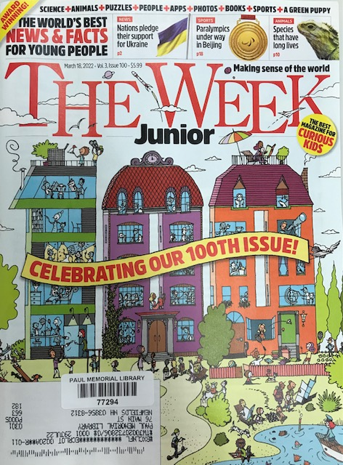
March 25th – April 30th, 2022
- I) Check out The Week Junior Magazine from the Kids Room.
- 2) Read through the magazine and find something that interests you.
- 3) Write 3 - 5+ sentences about your favorite article telling us why you like it.
- 4) Be sure to include the magazine date and the page number of article
- 5) Bring it to us and Win a Prize from our Treasure Chest!
Or
- Draw a picture about your favorite article on the back of your sheet. Be sure to include date of magazine and page number of article. You can submit an original or photo copy of your drawing.
- We will display submissions at the library.
- Materials won’t be returned, so be sure to give us photo copies if you want to keep your originals.

- Title of Article__________________________________________________________
- Date of magazine._______________________Page Number._____________________
- Why do you like this article?
_______________________________________________________________________

________________________________________________________________________

________________________________________________________________________

________________________________________________________________________

________________________________________________________________________

________________________________________________________________________

________________________________________________________________________

______________________________________________________________________

OR add your drawing submission on the back.

